Code Review 1: Wound Healing Simulation

Student Y, Date

# Introduction:

This code review was done with code from Student X. X is writing a simulation for wound healing in Starlogo Nova. The following review discusses the behavior of her bacteria agents.

# Code Review:

We are first starting this code review in the Bacteria Agent tab of the code. Figure 1 displays two blocks of code that determine the behavior of the bacteria in X’s simulation. While the forever button is pressed she has two nested IF loops. The first IF loop checks if the bacteria are alive, denoted by the color brown. If they are brown the will move around the arena; each clock tick they will move forward two spaces, turn left by 0-14 degrees and then turn right by 0-14 degrees. Then, as a result of the nested IF loop, there is a 5% chance that the bacteria will produce one ‘Chemokines’ agent. So the overall behavior of the bacteria is to move around in a ‘biological way’ and to spawn chemokines. The spawning of chemokines from the bacteria is a simplification of how a wound response actually works biologically. The chemokines are really produced by the infected tissue. However, X does not have a ‘tissue’ agent to release the chemokines therefore she has the bacteria produce the chemokines.

The detection block of code states that if the bacteria is ‘dead’, represented by being black in color, the bacteria agent will be deleted when a macrophage makes contact. This represents the macrophages clearing debris left behind by dead bacteria.

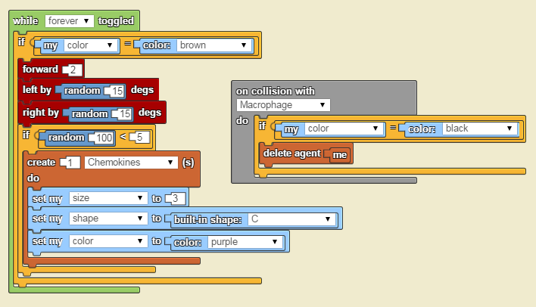

Figure 1: Code in the Bacteria Agent Tab for Their Behavior.

# Discussion and suggestions:

Upon review of this code, I suggested a few additions to make this simulation approximate the biology of wound progression and infection slightly more completely. First, the code needs a function that causes the bacteria to turn black (die) once they come into contact with the Neutrophils. It also might benefit from the bacterial not moving when they are black (dead).

Another suggestion would be for the bacteria to move slightly more sporadically. They seem to be moving in a very straight line due to such a small turning angle.

Additionally, I think it would be interesting to not have any bacteria from the beginning and just have the ‘infection’ button create bacteria on demand to simulate before the wound occurs and then when the infection starts.

Finally, it would be very good to create a bacteria doubling time. This would simulate the proliferation of bacteria over time.